Elastic Search

A word on document types

I need to steal your attention for a moment to talk about *mapping types*. These were a thing for older versions of Elasticsearch, but will be removed in version 8.x. They are already deprecated and are only available when actively opting into using them. However, this means that pretty much all endpoints for the Elasticsearch API has changed. Whenever you see default as part of an endpoint, this refers to the mapping type.

We have been using queries that are compatible with Elasticsearch 7.0.0 and later until now, but you are about to see some queries that use a type of default. The reason for that is that those lectures were recorded before _doc was a thing. Some APIs now use _doc instead of default, while others completely got rid of that part of the endpoint. For the queries that contain default, please check the [GitHub repository for the updated queries](https://github.com/codingexplained/complete-guide-to-elasticsearch). The difference is just semantics, so hopefully it won't be an issue for you.

For instance, when you see the following:

GET /products/default/_search

... you should replace it with:

GET /products/_search

I am gradually updating the course with the latest queries, but please understand that re-recording and editing 10+ hours of content takes a long time, so there will be a period in which you will see the old document type being specified for parts of the course. This is a work in progress, and this document will be pushed forward as I make progress. 🙂 If in doubt, please refer to the [GitHub repository](https://github.com/codingexplained/complete-guide-to-elasticsearch).

Thank you for your understanding, and happy searching!

# Search methods

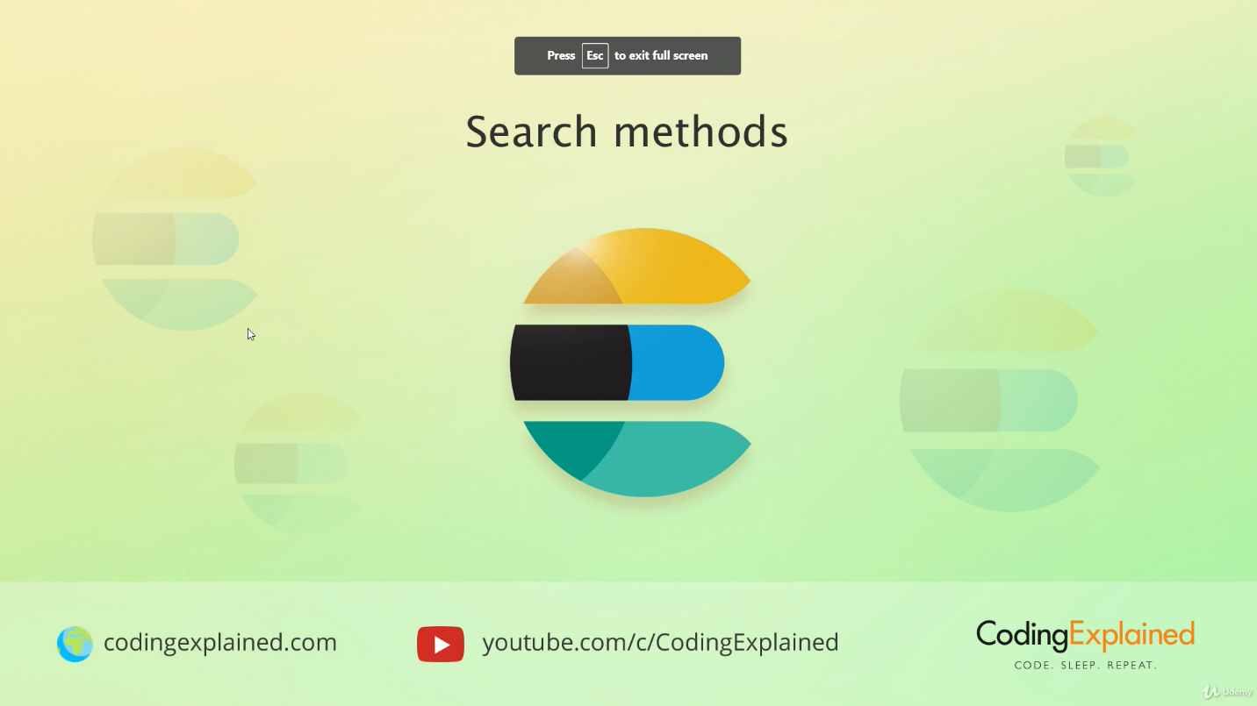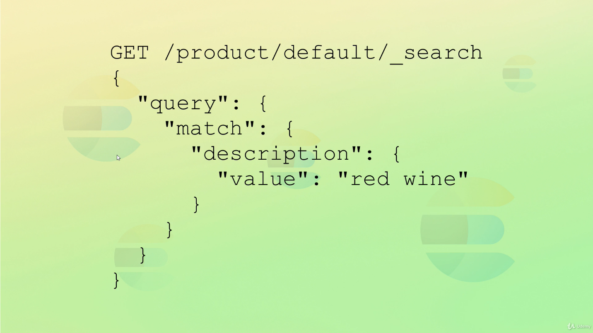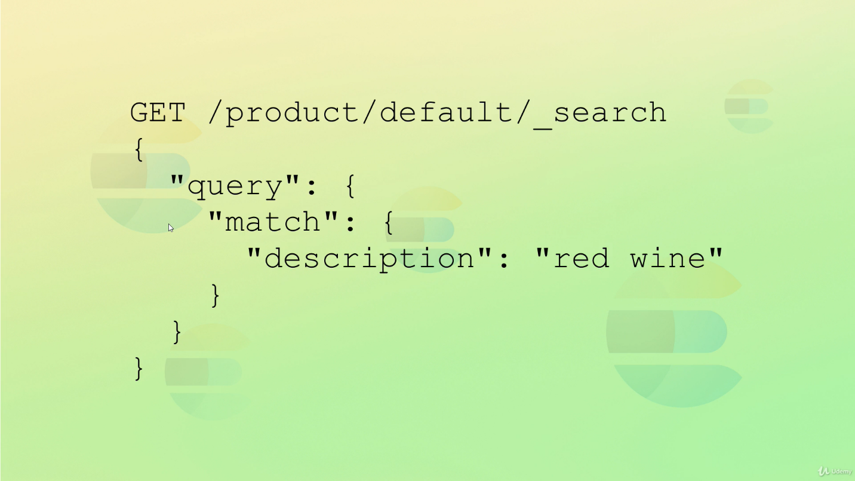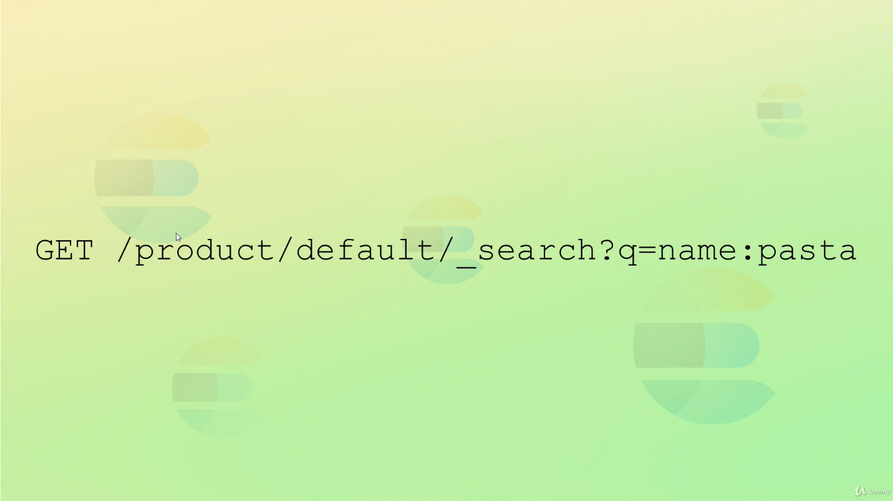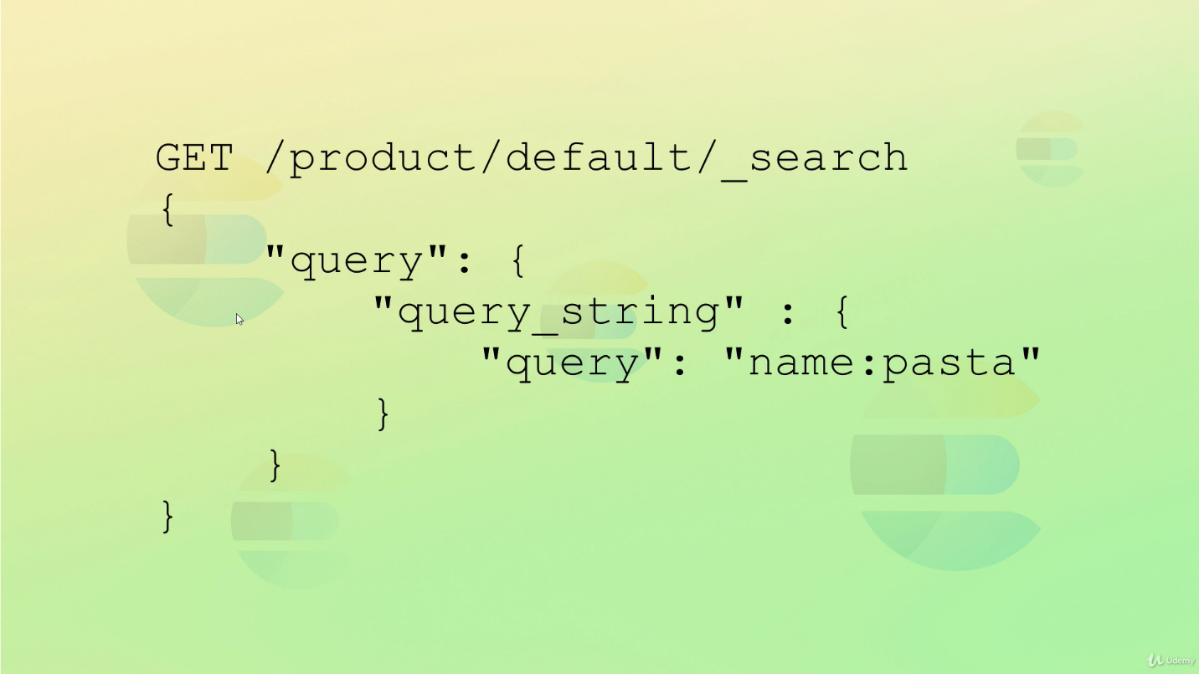

# Searching using URI

# Searching using query DSL

# 

# Working of search

# 

## Client send request to a node, this node will become coordinating node

## It will send request to other node and search on shards (can be replica or primary)

## Result received, will be compiled by coordinating node, and send back to client

# Understanding query results

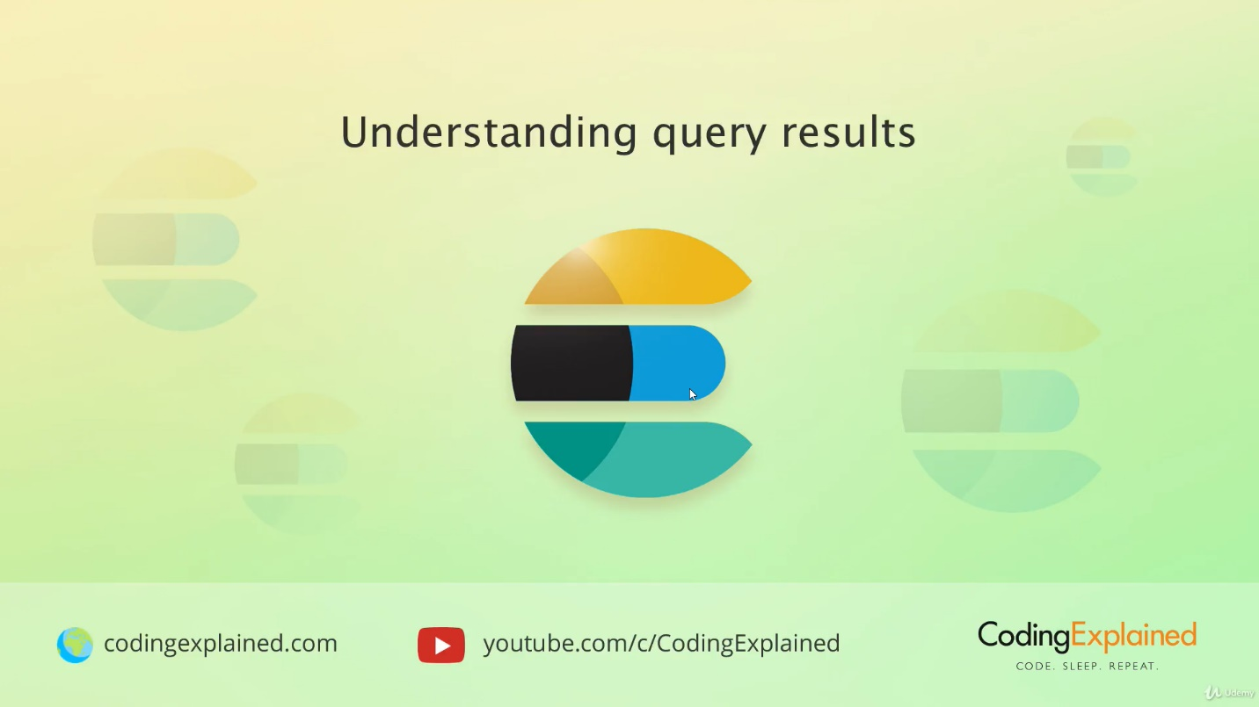

## Took- time taken to search

## Timed out – whether timedout or not

## Shards – number of shards it search on

## Hits- total – total results found, maxscore- relevancy

## By default it return 10 results, but it can be modified

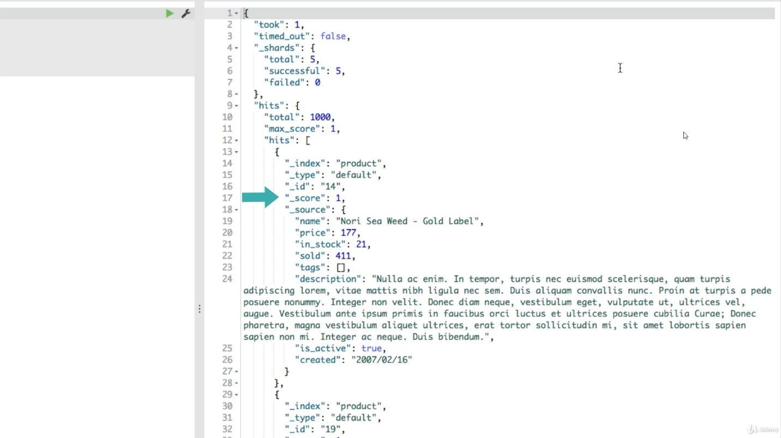

# Understanding relevance score

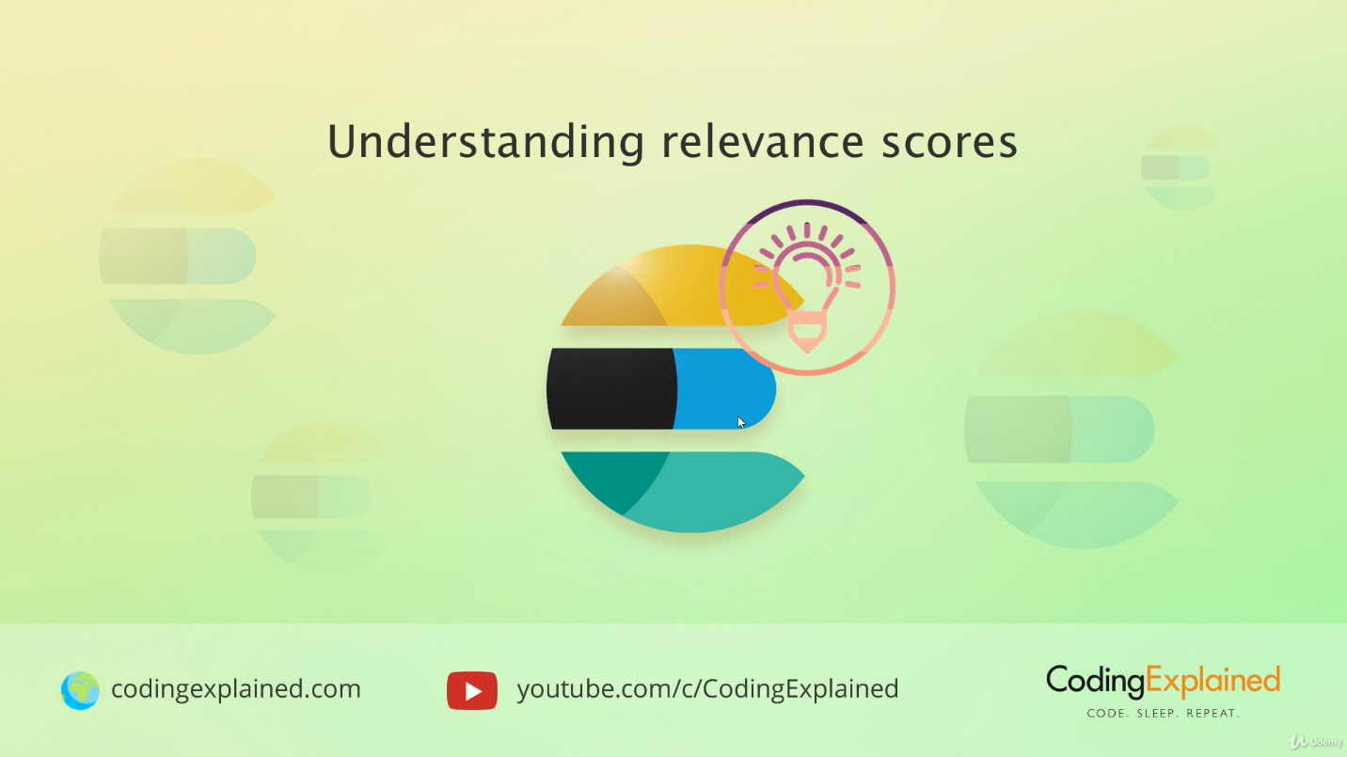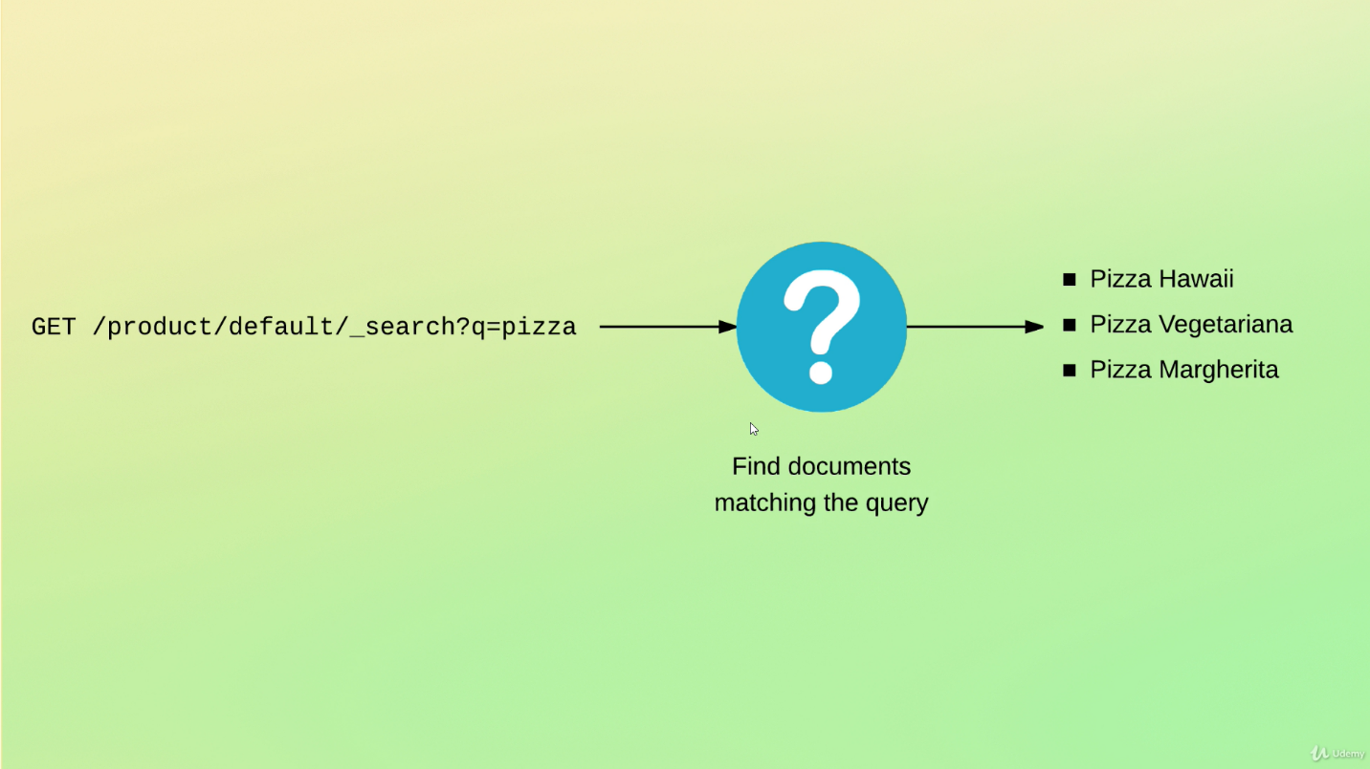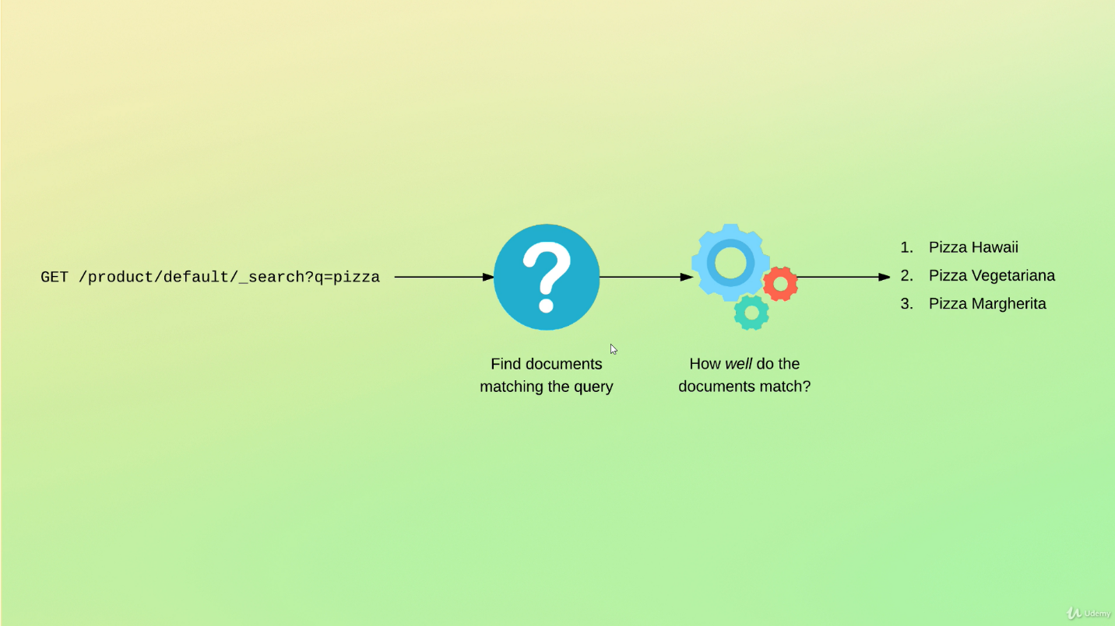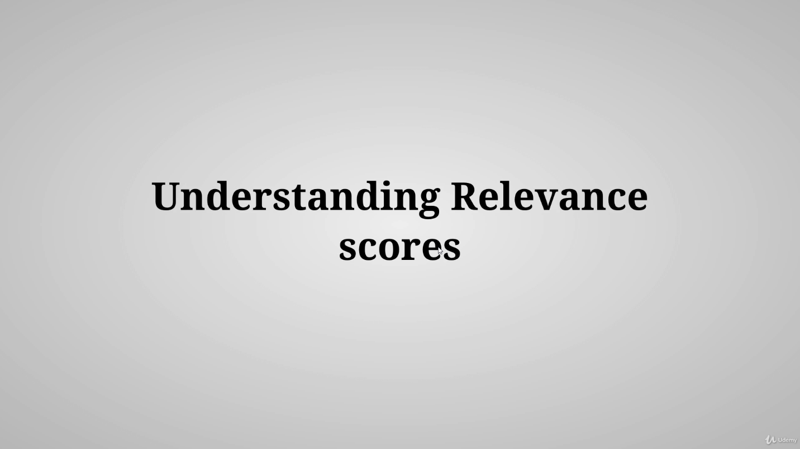

## Earlier ES used TF/IDF, now okapi BM25

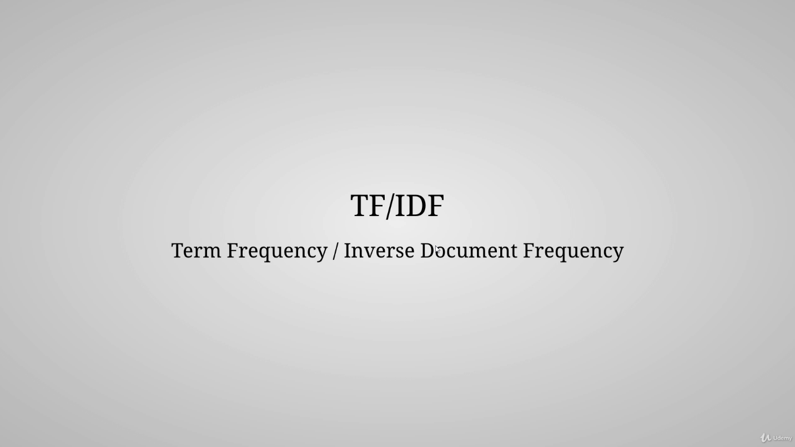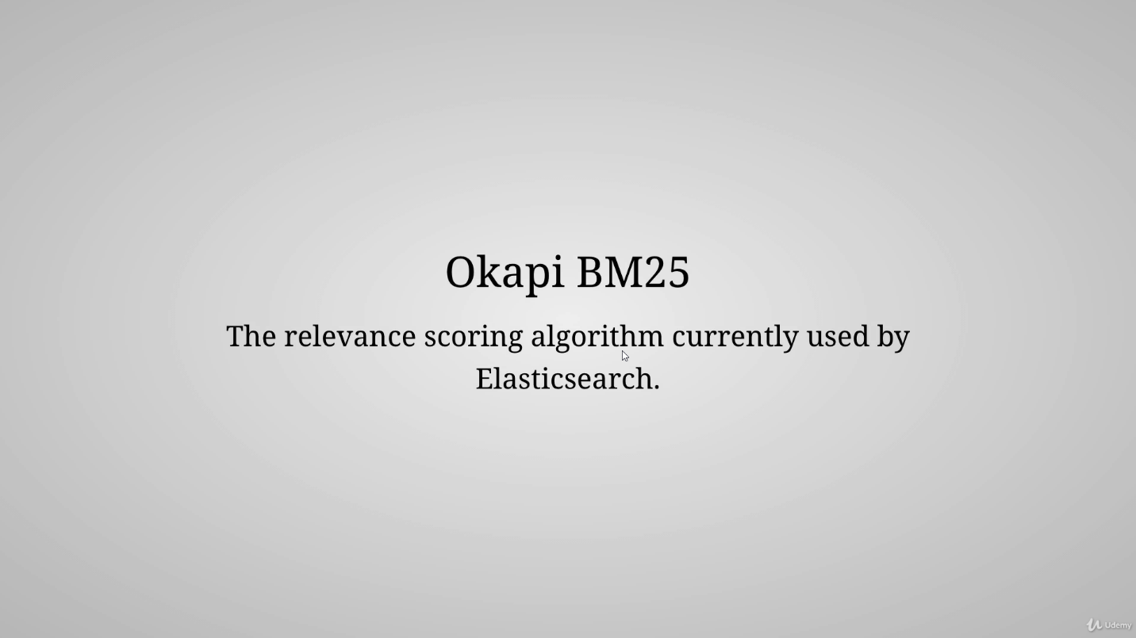

## If search term comes twice in field it will have higher relevance than if it comes single time

## If a search term comes in more documents it will have less relevance, as it may be stop word

## Search term present in 50 word field has more relevance than in 5000 word field

# Comparison with bm25 algorithm

# 

## TF keep increasing relevancy if frequency is higher, while it get saturated in BM

# Debugging unexpected search result

# 

## Get /index/default/:id/_explain

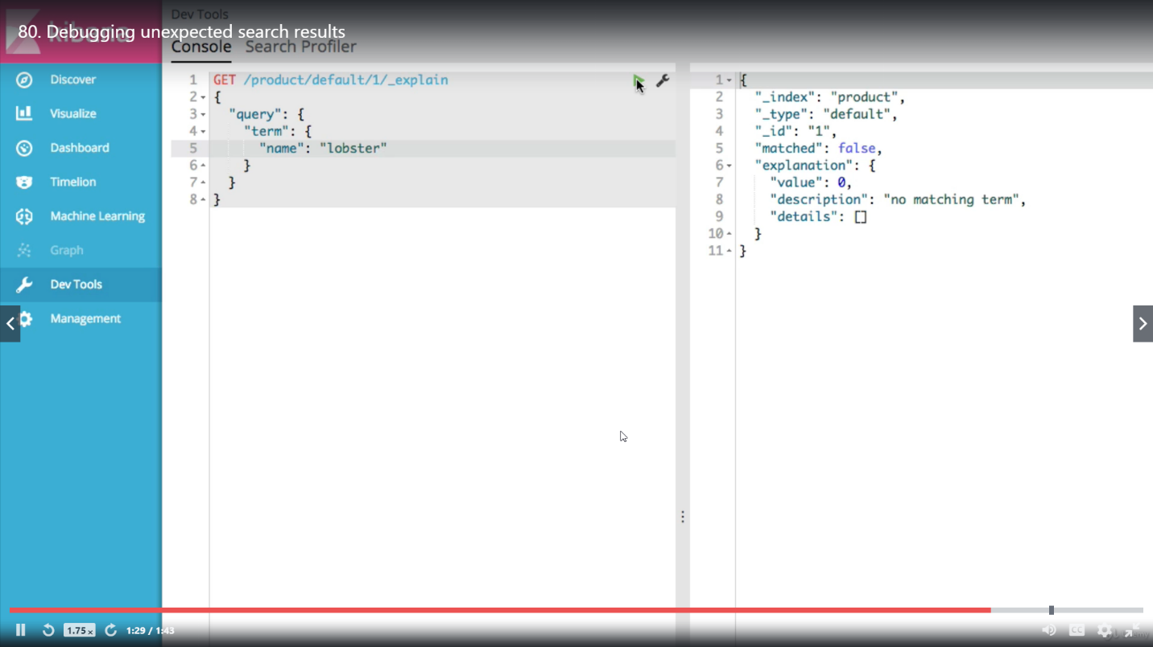

# Query context

## Query context affect relevance

## Filter context doesnot



# Full text query vs term level query

## Term level query does not search in document but in inverted index.

## As we know inverted index are saved after analyzing (lower case, root etc)

## Lobster in capital is not present in inverted index

## 

## Match (full text) query search after getting analyed

# Introduction to term level queries

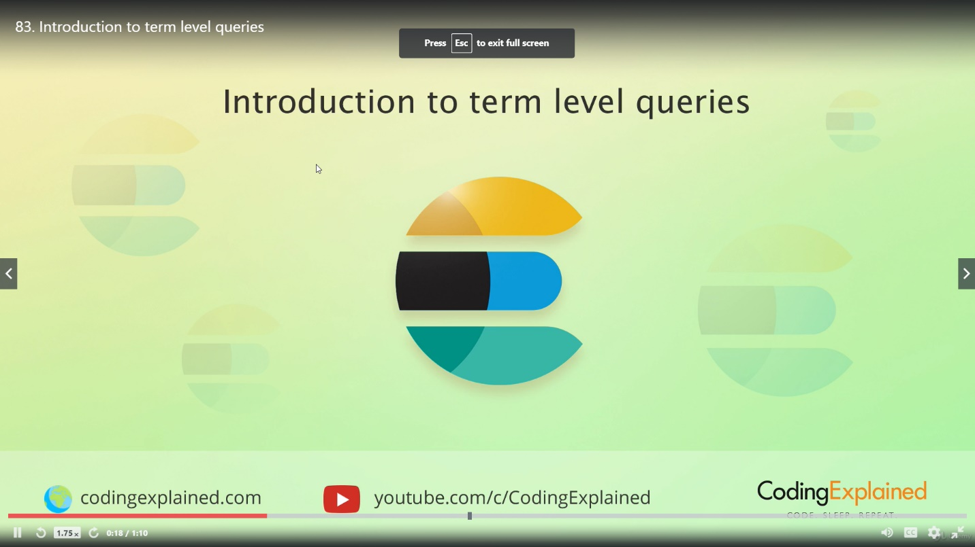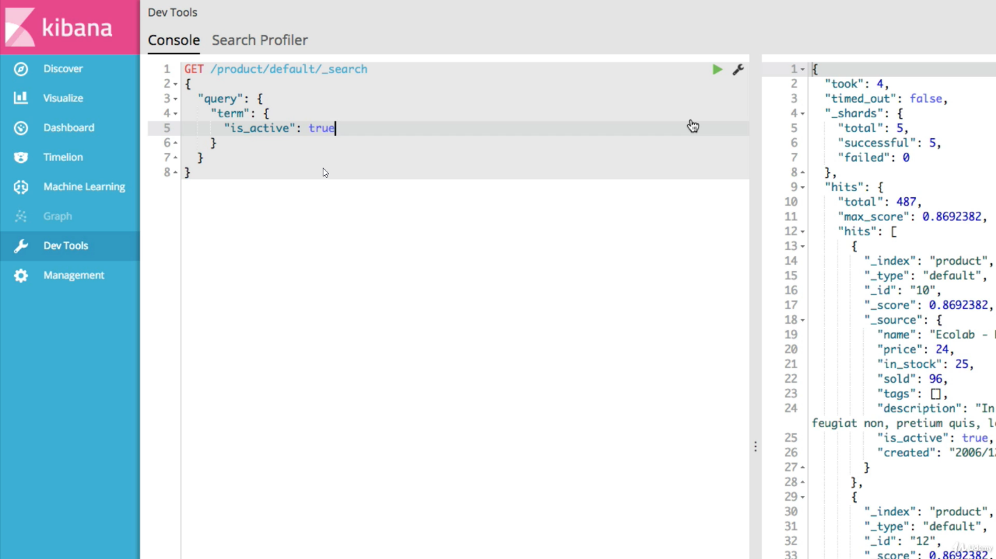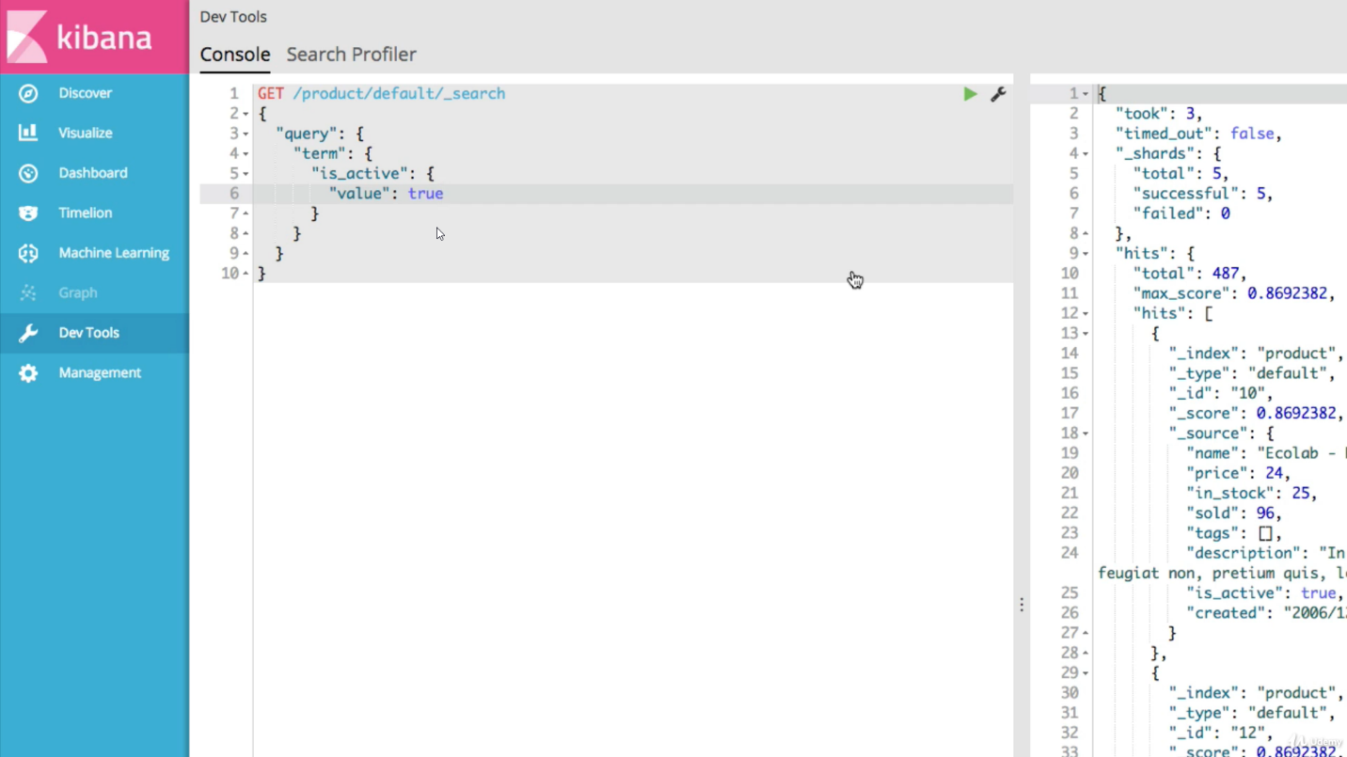

## Searching multiple term

## It is same as ‘in’ in RDB

## Searching using range value

## Gte = greater than equal

## Using custom date format

## Working with relative dates

### Use date and || to use this date as anchor point for calculation

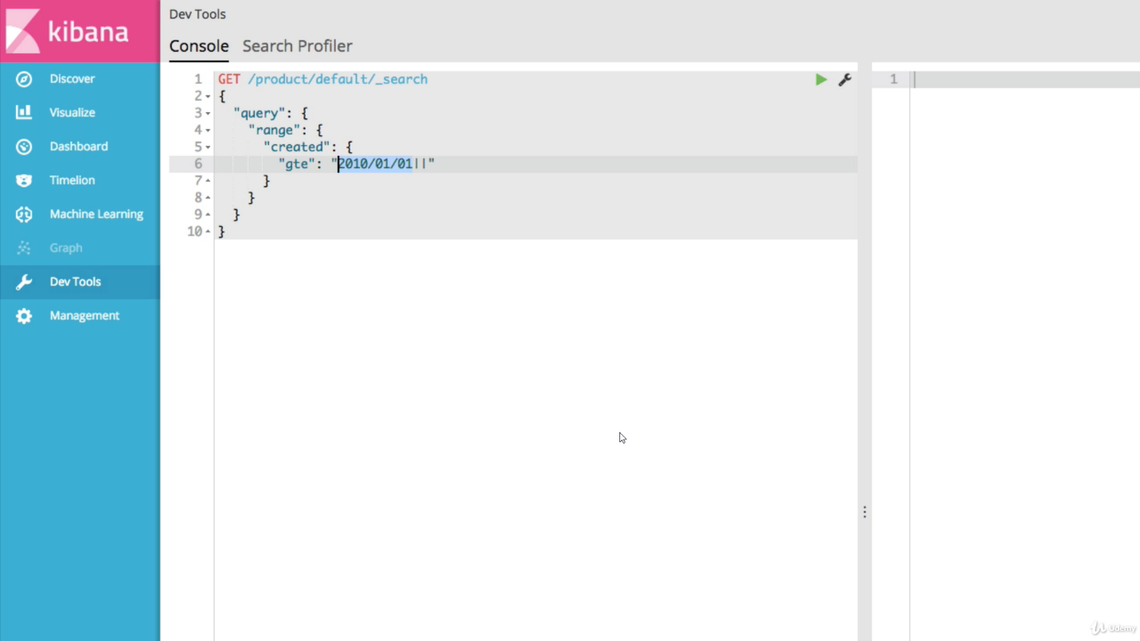

### Subtract 1 year from anchored date

### Subtract 1 year and 1 day from anchored dateRounding up month after subtracting year

### Rounding up month before subtracting year

### Use keyword “now” for current date and time

## Matching documents with non null values

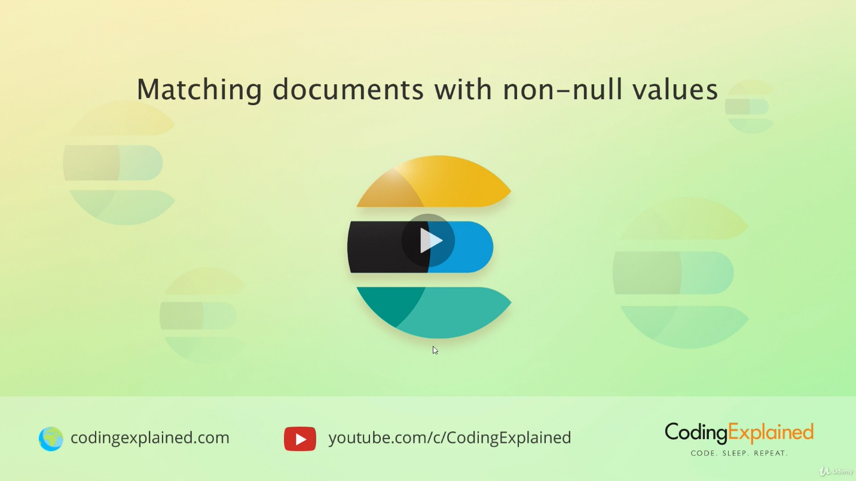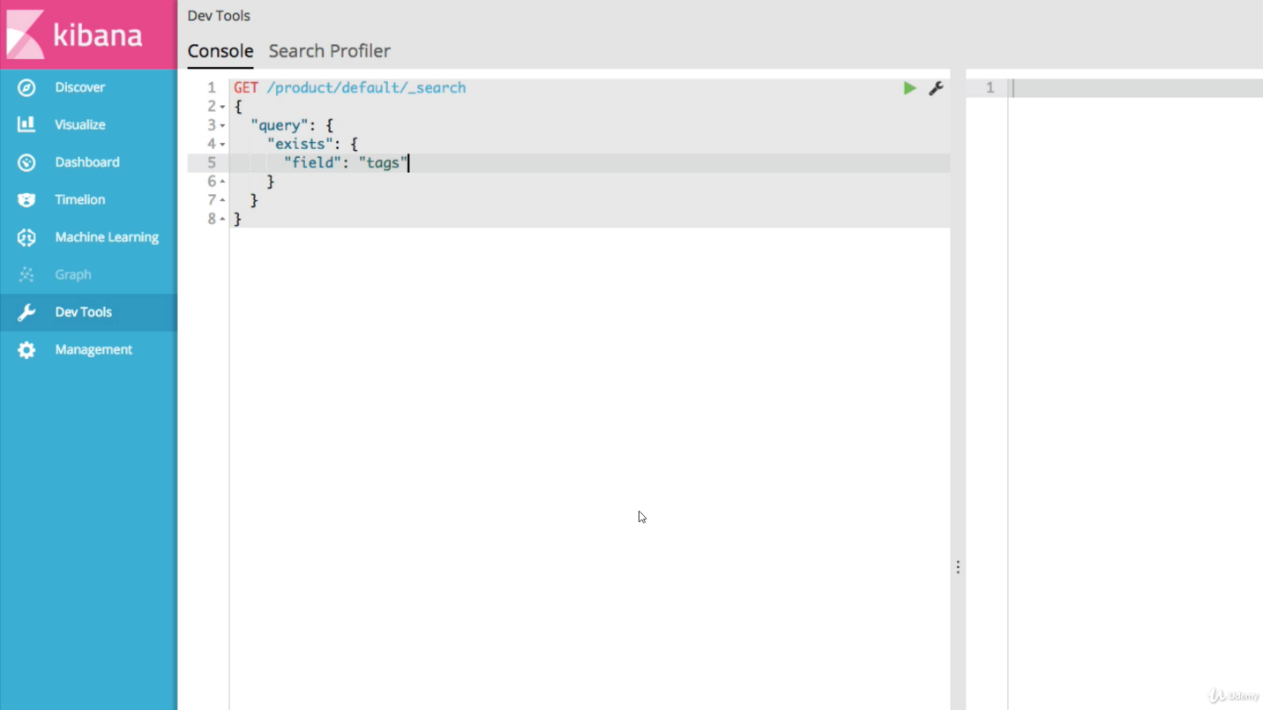

## Matching based on prefixes

## Searching with wildcard

## ?represents 1 character only

## Searching using regular expression

### ES supports lucene regex therefore some expression are not available such as anchored expression. Also /d /s etc

# Introduction to full text queries

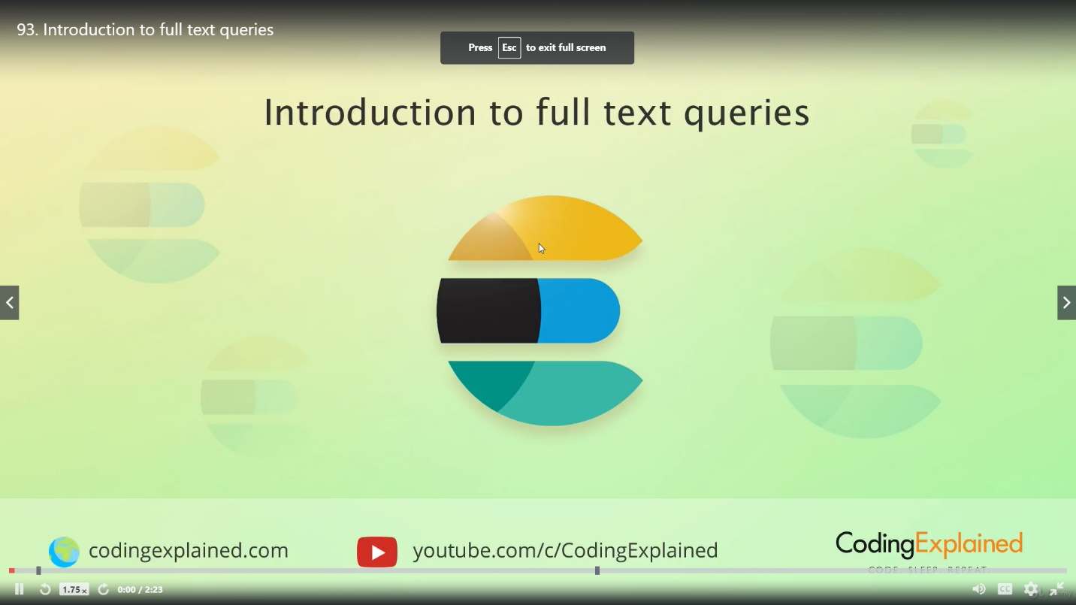

## By default it does not search for stopping words

## All the words all searched with or operator, more the word come higher the relvance

## Changing operator to AND

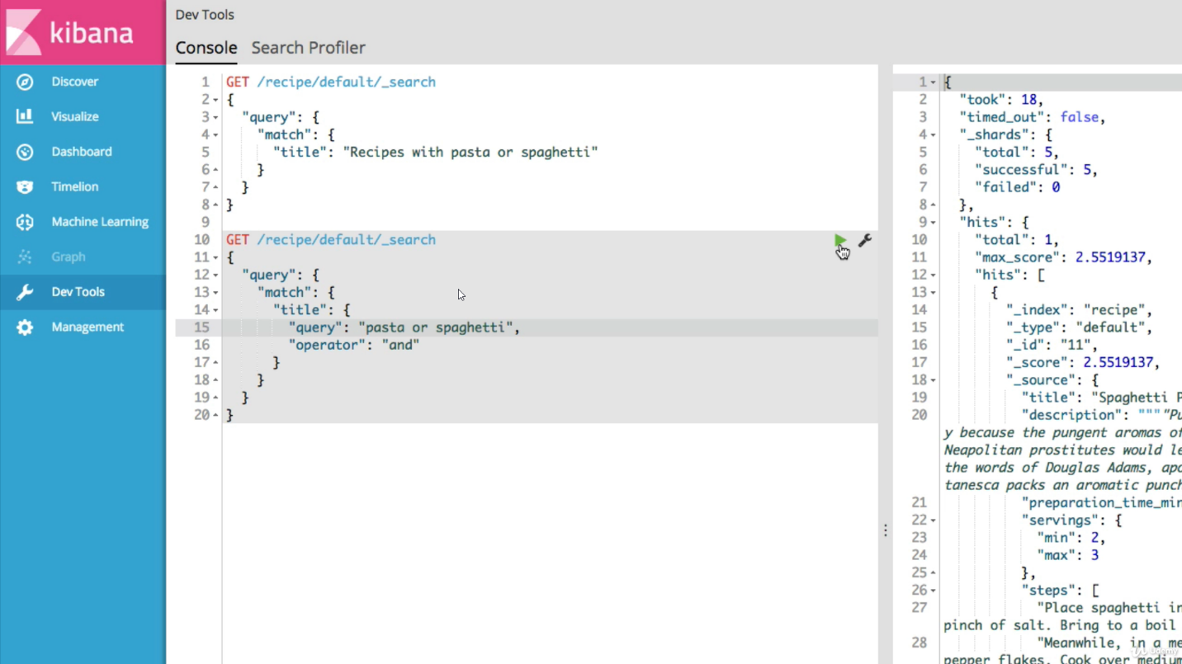

## Matching phrases –i.e. in exact order

## Searching multiple fields